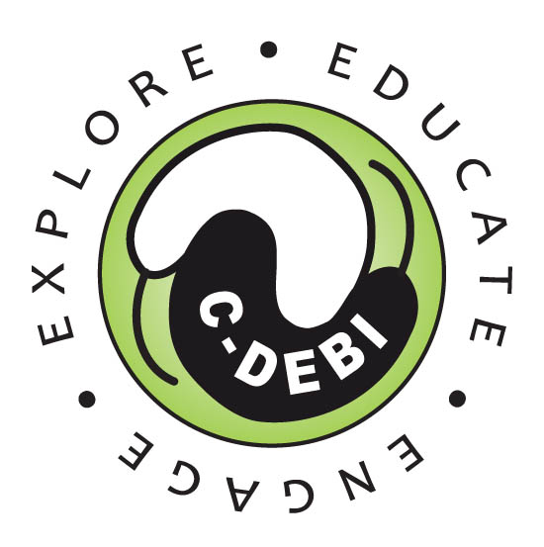

C-DEBI K-16 Educator Small Grants
Awards up to $2500
Deadline: May 1, 2016

C-DEBI’s mission is to explore life beneath the seafloor and make transformative discoveries that advance science, benefit society, and inspire people of all ages and origins. Our education and outreach goals toward that mission include creating distinctive, targeted education programs and promoting increased public awareness about life below the seafloor.

The C-DEBI K-16 Educator Small Grants program supports K-16 educators who have attended a C-DEBI teacher training program and have incorporated C-DEBI content into their classrooms. These grants support items including but not limited to the following: funds for student field trips, classroom supplies, travel for presenting C-DEBI curriculum at educator meetings, or additional professional development directly related to C-DEBI research. Proposals for funding should indicate how C-DEBI research content is being translated into the classroom and how the proposed activities connect to that content. The proposal may include multiple items as long the connections between those items are outlined.

Grants will be awarded up to $2,500 and limited to one per educator per academic year. Educators serving diverse or low-income students are encouraged to apply. This funding is only available to individuals sponsored in US institutions.

A complete application consists of the following:
- Cover page including name, school and mailing address, grades taught and eligible training attended
- Proposal (1-2 pages) detailing the project and a statement agreeing to provide a 1-2 page report to C-DEBI on the outcomes of the award
- Budget (1 page) itemizing expected costs and total amount requested (e.g., classroom supplies, lab supplies, ROV supplies, field-trip support, teacher professional development support, conference presentation)
- Curriculum vitae or resume
- A letter of support from a school administrator or department chair

Please submit your proposal by email to Dr. Stephanie Schroeder (Education, Outreach, & Diversity Managing Director) at slschroe@usc.edu.

Example teacher training programs: - C-DEBI Programs (e.g., Community College Instructor Workshops, Global Environmental Microbiology) - COSEE-West Teacher Workshop “Investigations of the Deep Oceans” - COSEE-West Online Teacher Workshop “Ocean X-Factor: Life Beneath the Deep” - MBARI EARTH Workshop - C-DEBI/College of Exploration collaborations

